**DAILY ONLINE ACTIVITIES SUMMARY**

|  |  |  |  |  |  |  |  |  |
| --- | --- | --- | --- | --- | --- | --- | --- | --- |
| **Date:** | **29/05/2020** | | | | | **Name:** | **Lavanya D M** | |
| **Sem & Sec** | **4th & ‘A’** | | | | | **USN:** | **4AL18CS041** | |
| **Online Test Summary** | | | | | | | | |
| **Subject** | | **Operating System** | | | | | | |
| **Max. Marks** | | **30** | | **Score** | | | **28** | |
| **Certification Course Summary** | | | | | | | | |
| **Course** | **Web Page Design for Beginners** | | | | | | | |
| **Certificate Provider** | | | **Bitdegree** | | **Duration** | | | **3days,3hr** |
| **Coding Challenges** | | | | | | | | |
| **Problem Statement :1)** **Write a C Program to generate first N Armstrong Numbers**  **2)** **Write a Java program to Find size of the largest ‘+’ formed by all ones in a binary matrix** | | | | | | | | |
| **Status: complied** | | | | | | | | |
| **Uploaded the report in Github** | | | | | **Yes** | | | |
| **If yes Repository name** | | | | | <https://github.com/lavanyamurthi/lockdown-coding> | | | |
| **Uploaded the report in slack** | | | | | **Yes** | | | |

Online Test Details: (Attach the snapshot and briefly write the report for the same)

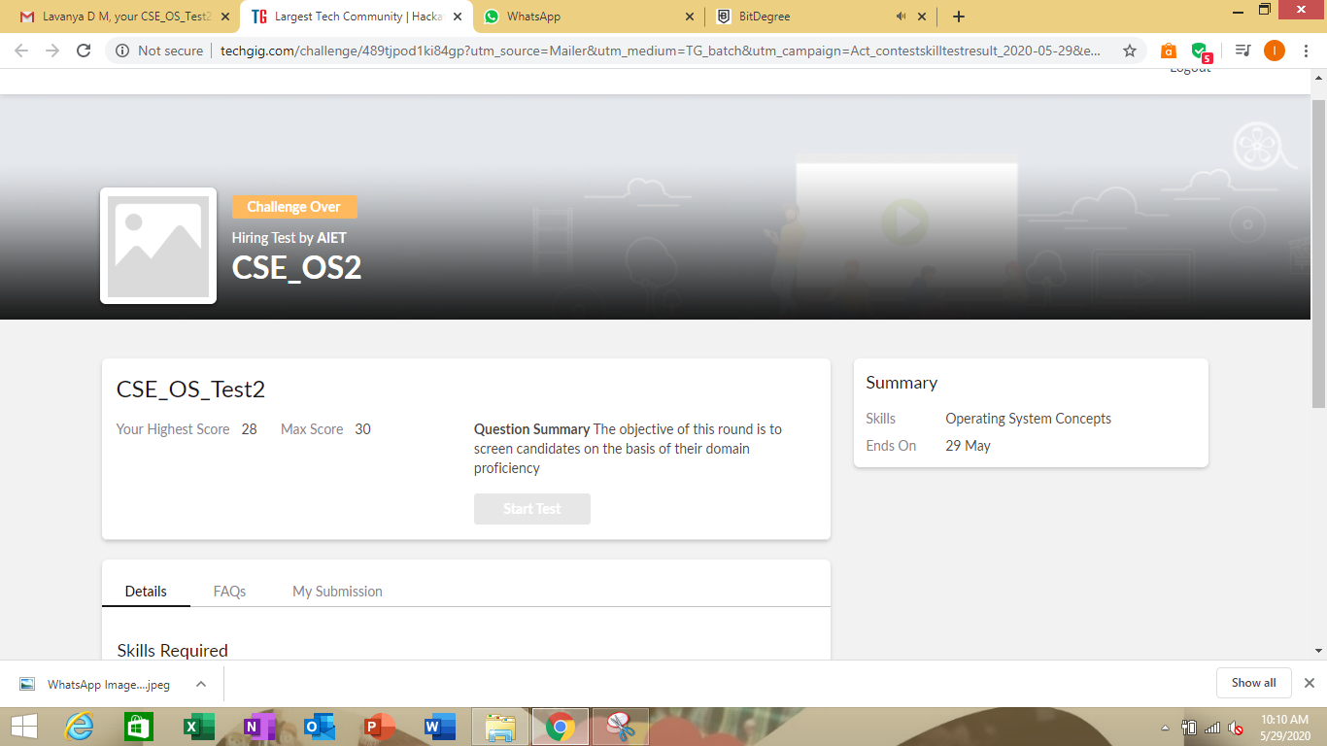

Certification Course Details: (Attach the snapshot and briefly write the report for the same)



Today I learned about the layout, medium and graphics

GitHub link <https://github.com/lavanyamurthi/lockdown-certificate>

Coding Challenges Details: (Attach the snapshot and briefly write the report for the same)

Problem1:

Write a C Program to generate first N Armstrong Numbers   
Armstrong number is a number that is equal to the sum of cubes of its digits. For example 0, 1, 153, 370, 371 and 407 are the Armstrong numbers.

Example 1:  
Let's try to understand why 153 is an Armstrong number.  
153 = (111)+(555)+(333)  
where:  
(111)=1  
(555)=125  
(333)=27  
So:  
1+125+27=153

Example 2:  
371 = (333)+(777)+(111)  
where:  
(333)=27  
(777)=343  
(111)=1  
So:  
27+343+1=371

}

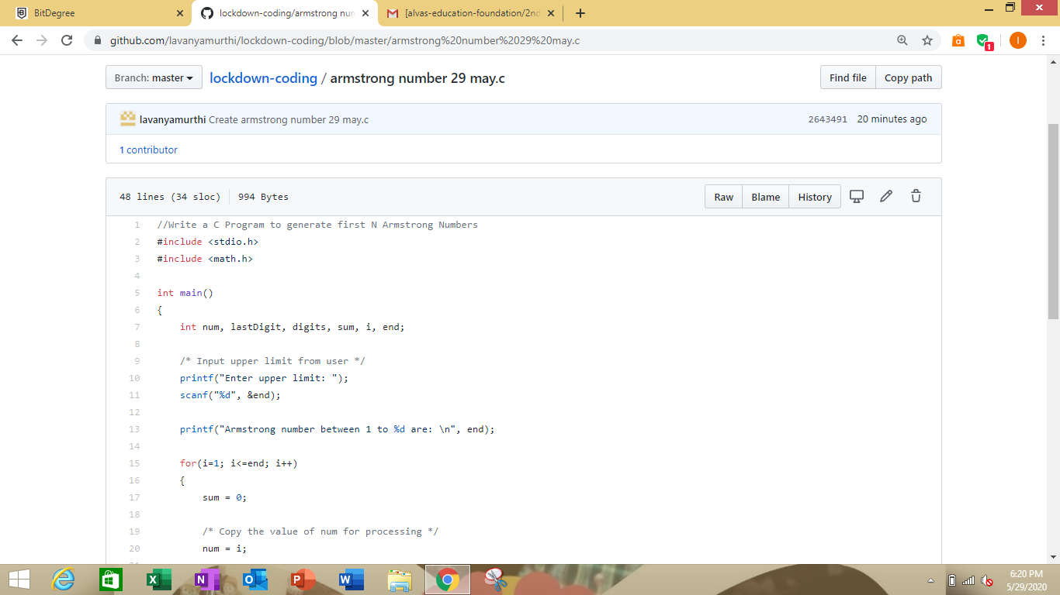

Problem2:

Write a Java program to Find size of the largest ‘+’ formed by all ones in a binary matrix

Given a N X N binary matrix, find the size of the largest ‘+’ formed by all 1s.

For above matrix, largest ‘+’ would be formed by highlighted part of size 8.

The idea is to maintain four auxiliary matrices left[][], right[][], top[][], bottom[][] to store consecutive 1’s in every direction. For each cell (i, j) in the input matrix, we store below information in these four matrices –

left(i, j) stores maximum number of  
consecutive 1's to the left of cell (i, j)  
including cell (i, j).

right(i, j) stores maximum number of  
consecutive 1's to the right of cell (i, j)  
including cell (i, j).

top(i, j) stores maximum number of  
consecutive 1's at top of cell (i, j)  
including cell (i, j).

bottom(i, j) stores maximum number of  
consecutive 1's at bottom of cell (i, j)  
including cell (i, j).  
After computing value for each cell of above matrices, the largest + would be formed by a cell of input matrix that has maximum value by considering minimum of (left(i, j), right(i, j), top(i, j), bottom(i, j) )

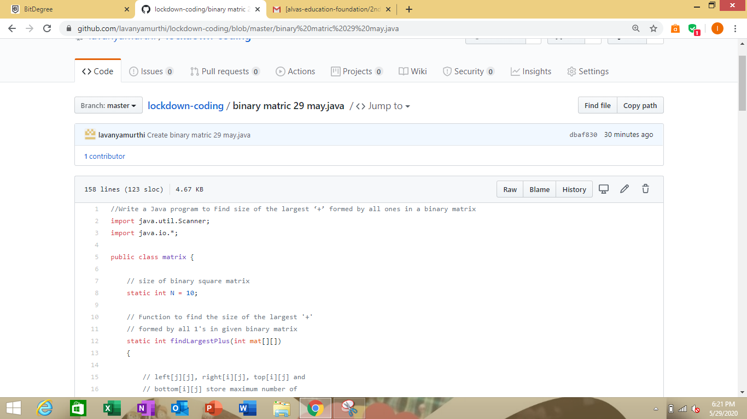

.

Here I provided the GitHub repository link of coded program

<https://github.com/lavanyamurthi/lockdown-coding/blob/master/armstrong%20number%2029%20may.c>

<https://github.com/lavanyamurthi/lockdown-coding/blob/master/binary%20matric%2029%20may.java>